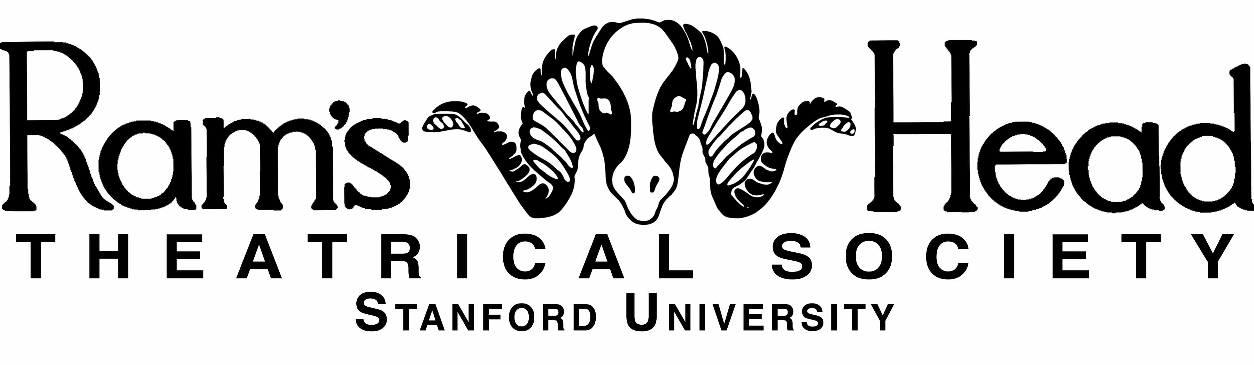

«Title»

An Original One Act

by

«Author»

Premiered «Premier\_Date»

Directed by «Director»

Originally produced by Ram’s Head Theatrical Society at Stanford University as part of the Original Winter One Acts «Year»

Copyright © «Year» by «Author»

All rights reserved

For more information, visit ramshead.stanford.edu

Macintosh HD:Lighting Design:Stanford:Ram's Head:Logos:Stanford Logo:SU_altSigSeal_Blk_pos.eps